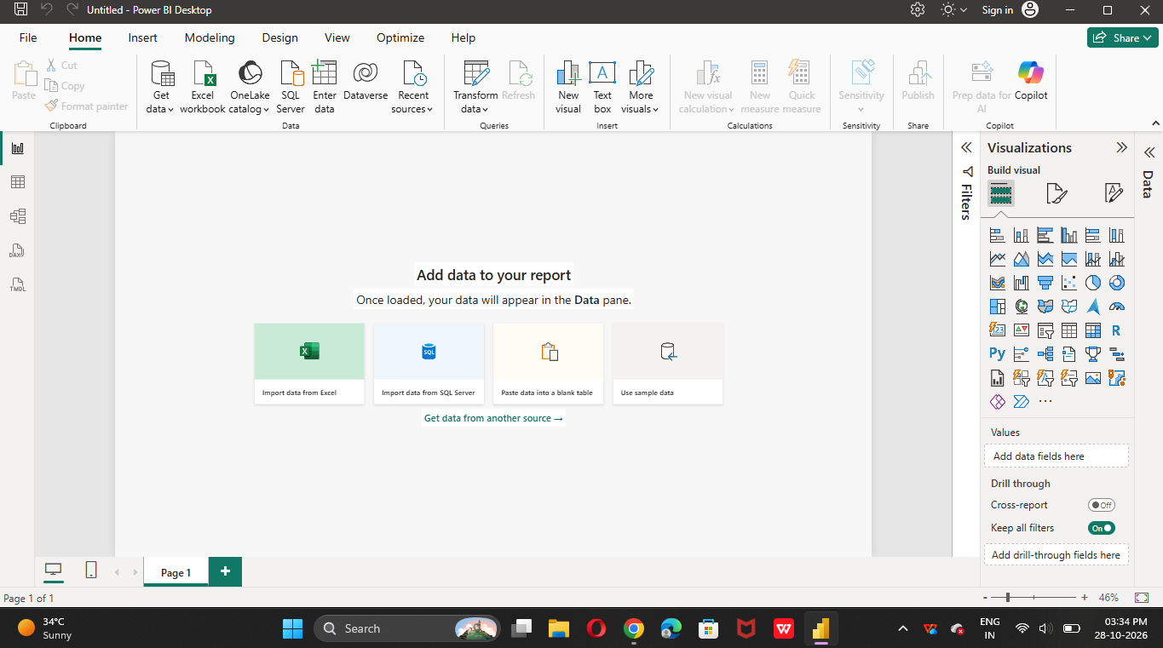
Task 2: Component.
Task 1: Screenshot of the blank report.
Task 1: Screenshot of the blank report.

Task 2 :
Report View: Report view is used to create and design interactive repost using charts, table, graphs, and other visualization to analyse data.
Data View: Used to view , explore , and check raw data in table format before creating report.
Model View : Used to create and manage relationships between difference in Power BI.
Field Pane: Display all available column and table s from your dataset. You can select fields to add data to your report.
Visualization Pane : Used to create charts, graphs, tables, and other element in Power BI.
Filter Pane: Used to filter data based on specific conditions, such as date, category, or region.

Task 3 : Difference between Excel and Power BI Dashbord

Feature Excel Dashboard Power BI Dashboard

Data Handling Used formulas, pivot Tables Uses Power query, DAX and and Charts. Data models.

Interactivity Uses slicers, filters, and Uses interactive filters,
Drop-downs. Slicers and drill-though.

Data refresh Often requires manual Supports scheduled and
Refresh or updating. Automatic data refresh.

